- For Section 1’s seven questions, the answers will be below in sequence with the first two bullet points being the screenshots for reference:
  - The GET message in Wireshark screenshot:
    - 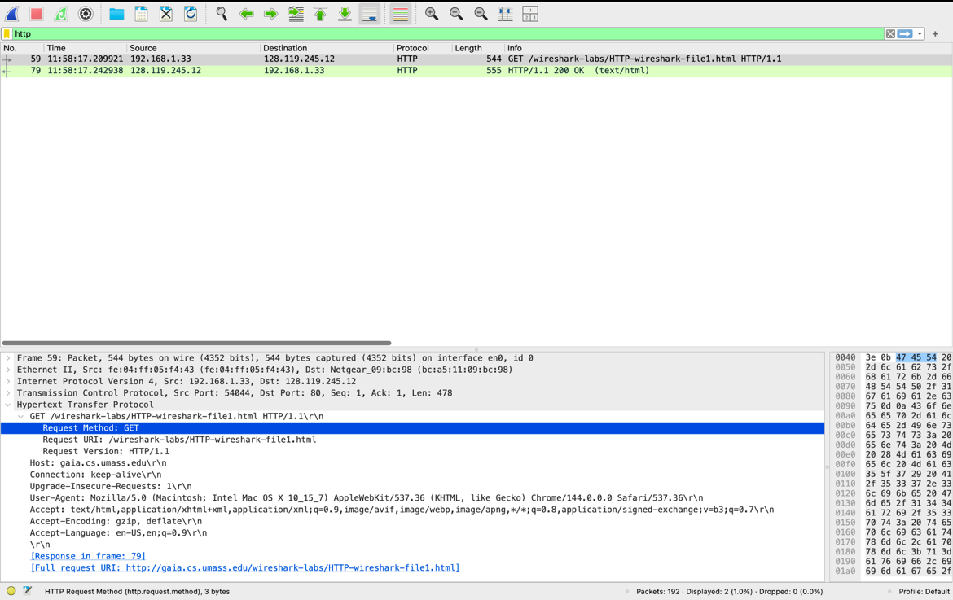
  - The OK message in Wireshark screenshot:
    - 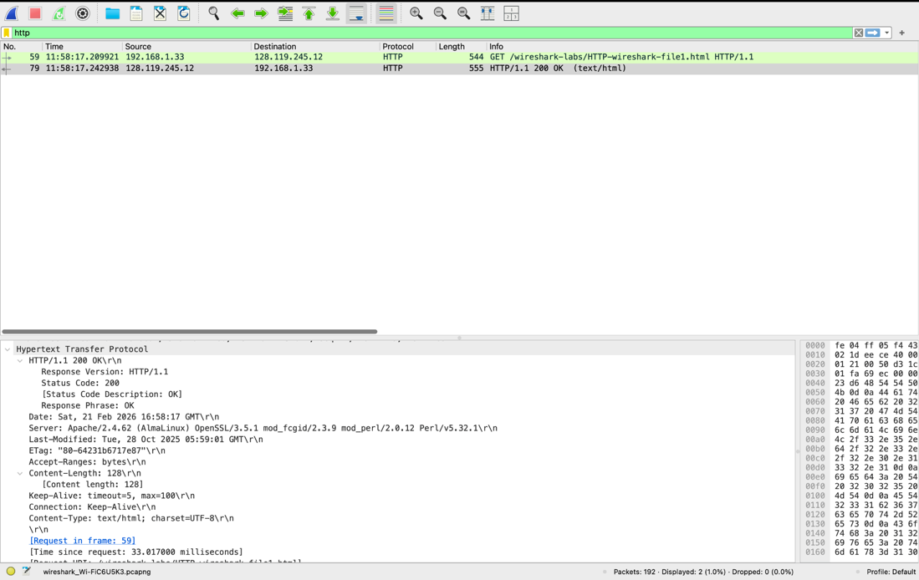
    - 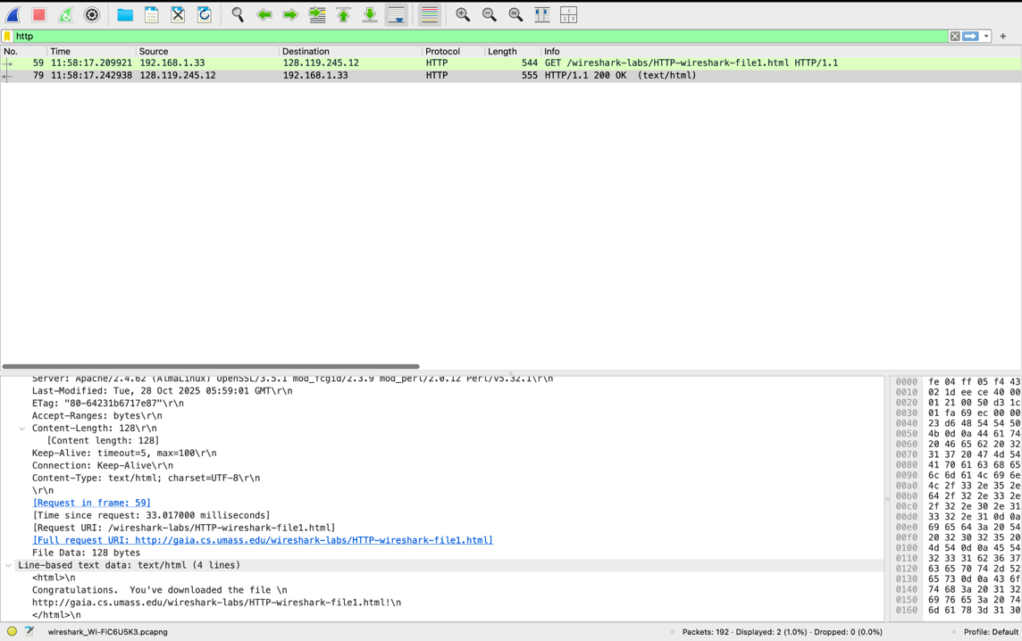
  - 1. In the GET message, in the first screenshot, under the Hypertext Transfer Protocol, there is a notification that states the “Request Version” which states the version of HTTP the browser is running on, which is “HTTP/1.1”. Then, above in the OK message, which is the first screenshot there, shows the version of HTTP the server is running on, which is “Response Version: HTTP/1.1”.
  - 2. It is indicated in the above screenshot for the GET message, that under the Hypertext Transfer Protocol, there is a section for the accepted languages, “Accept-Language”, and shows “en-US,en;q=0.9\r\n” which shows that US English has a 100% preference in my browsers in negotiation with the server, with the following “en” being the fallback language with a 90% (q=0.9) preference, should the server not have the specific US English version.
  - 3. Following the main window, the server’s and my IP address can be determined from the GET message’s line, with mine being the Source “192.168.1.33” and the server’s being the destination of “128.119.245.12”.
  - 4. In the above OK message’s first screenshot, under Hypertext Transfer Protocol, “HTTP/1.1. 200 OK\r\n”, it is further broken down to show that the “Status Code” that was returned from the server being “200” which is further described and transcribed to “OK” and that request was received, accepted, and responded to.
  - 5. As shown in the above OK message’s first screenshot, under the Hypertext Transfer Protocol, there is a field for the time and date that the HTML file I received was last modified, which is under “Last-Modified” with the data of “Tue, 28 Oct 2025 05:59:01 GMT\r\n” means that in Greenwhich Mean Time the file was last modified on that October 28 at 5:59.
  - 6. As shown in the OK message’s first screenshot, under the Hypertext Transfer Protocol, there is a field labeled “Content-Length” which displays a numerical value of “128” which is stating that the body/HTML file (not the HTTP headers, etc.) of what I asked for is 128 bytes long.
  - 7. There is a wealth of information and headers that are displayed in the Packet Content Window over the Packet Listing Window. There is the Hexidecimal/ASCII representation of the data, and other information is shown in the Packet Content and Details area which show the Date, the specific software and hardware of the server, the date the HTML file was last modified, the ETag (specific version identifier for the file, the Byte length of the file, how long the connection is kept open (“Keep-Alive”), and that the browser is rendering the webpage using UTF-8 encoding, among other information!
- For Section 2’s four questions will be answered below in sequence with the first few bullet points being the screenshots:
  - Below is the screenshot for the first HTTP GET request from my browser (before refresh request):
    - 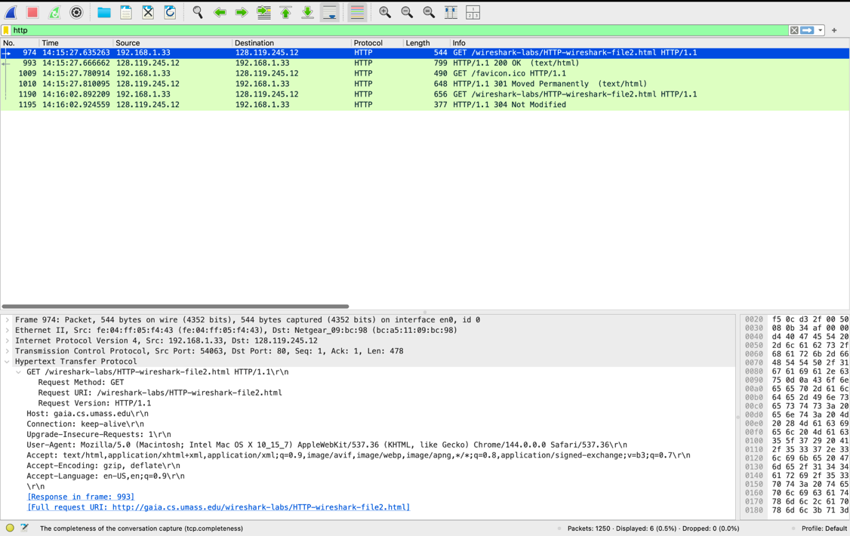
  - Below are screenshots from the first OK message that I received from the server after my initial URL request:
    - 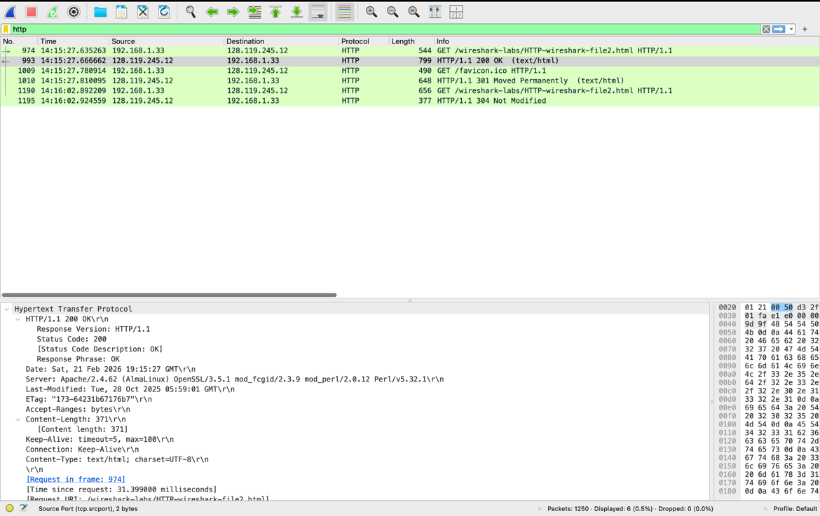
    - 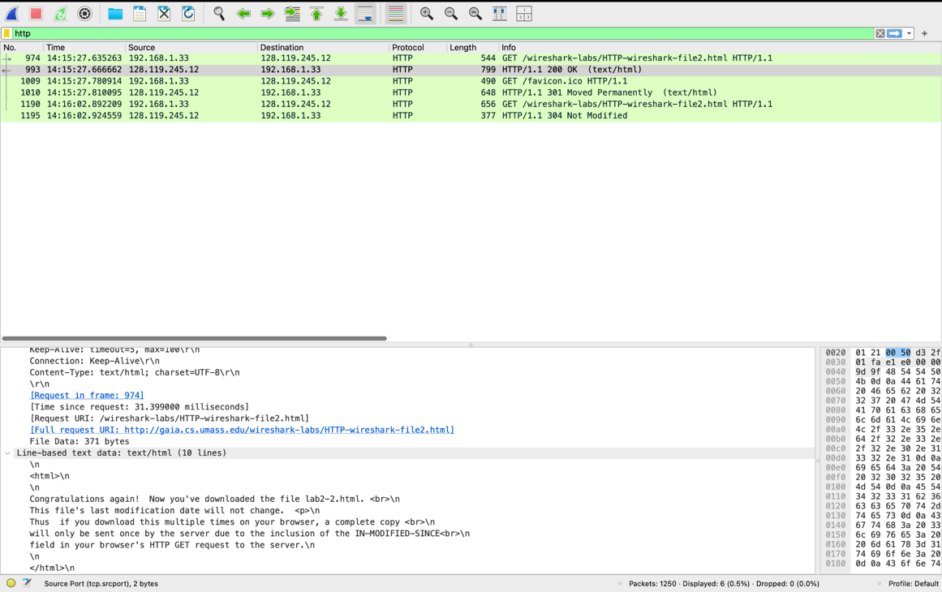
  - Screenshot of the last GET message (line 5):
    - 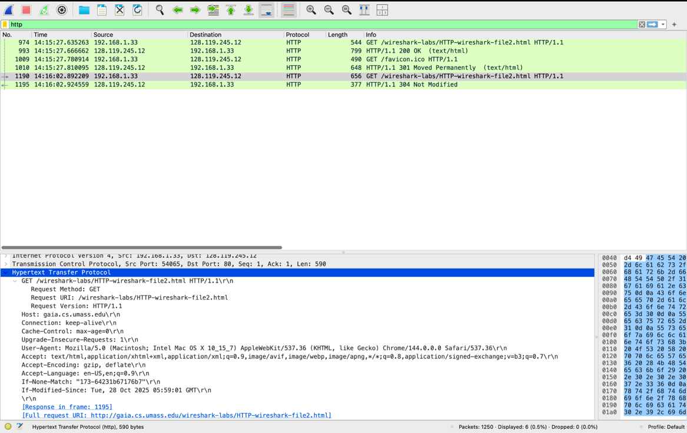
  - Screenshot of the last OK message (line 6):
    - 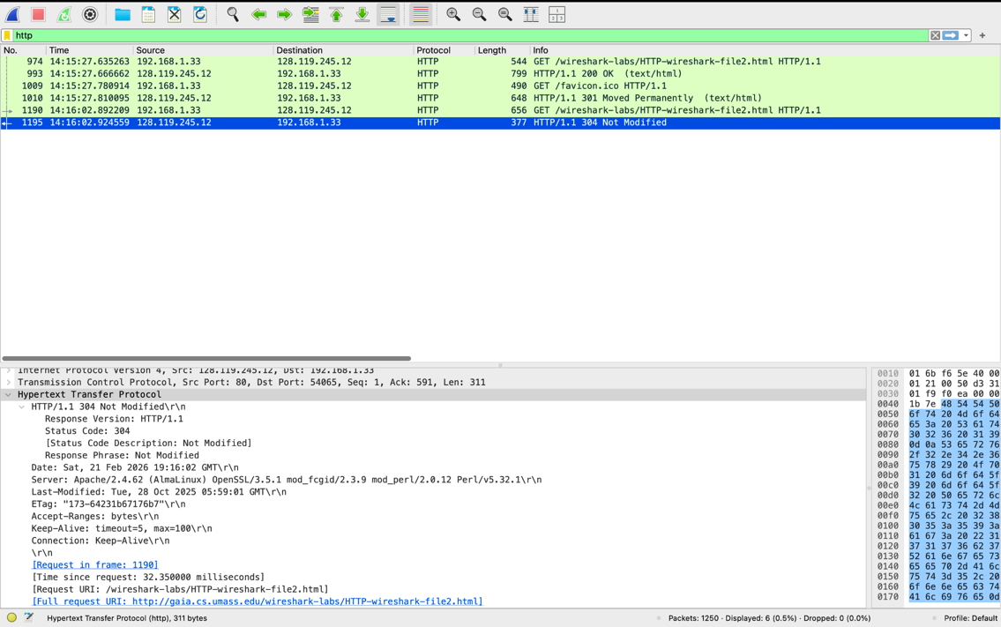
  - 8. As shown above in the first HTTP GET request from my browser, there is not an “IF-MODIFIED-SINCE” line in the HTTP GET.
  - 9. As shown in the screenshots for the first OK message, details that communicate to me that the server explicitly returned the contents of the file are: 1. At the bottom of the second screenshot there is the full line-based text data of the HTML file; 2. In the first screenshot of the first OK message, the server returned that there are 371 bytes, which happens when the server returns a file so that the browser knows when the download is finished; 3. Finally the HTTP status code of 200 is the standard response for a successful HTTP request where the server provided the entity requested.
  - 10. To clarify, as shown in my screenshots, I have 6 lines with 3 GET and 3 OK messages, with the first two GET and OK messages being from my initial search of the URL, the second from my computer and server fetching the Icon, and the last 2 GET and OK messages being from me refreshing. Since the questions seem to focus on the first two and not the last two, the only other set of screenshots that this question and question 11 are going to refer to will be of the last two GET and OK messages. As shown in the screenshot for the GET message in Line 5, there is an “If-Modified-Since” header which has the data of “Tue, 28 Oct 2025 05:59:01 GMT\r\n”. So this is grabbing the “Last-Modified” date and time from the original GET request, and asking the server when it refreshes if the file has been updated since that date.
  - 11. As a continuation of question 10, with the use of the screenshot of the line 6 OK message, since the file had not been modified since I had last requested in, the response from the server is a 304 status code, which means that instead of sending all 371 bytes again when nothing has changed instructs my computer to use the copy it already has in order to save bandwidth.
- For Section 3’s four questions, the answers will be below answered sequentially with screenshots preceding the answers:
  - There ended up being on my window 1 HTTP GET message and 1 HTTP OK message (with 1 GET and OK message for the icon), here is the screenshots for the HTTP GET message:
    - 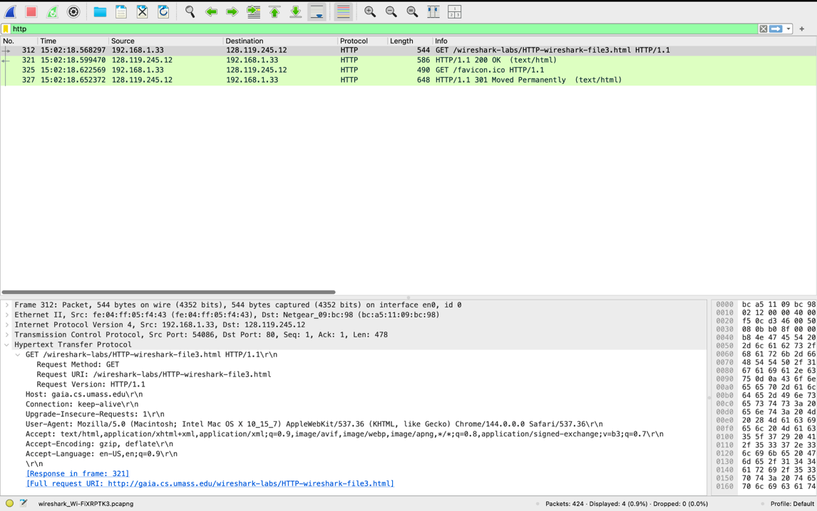
  - Here is the screenshots for the HTTP OK message:
    - 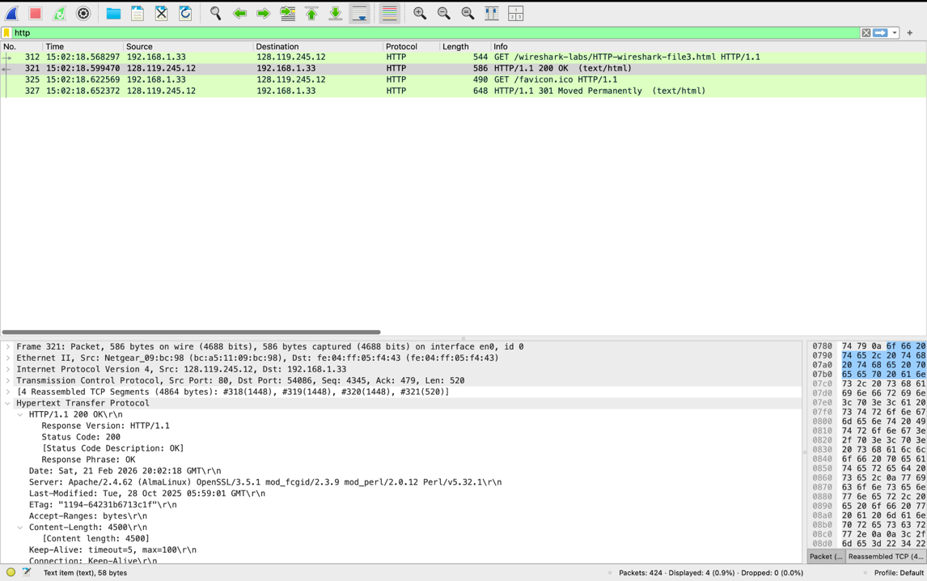
    - 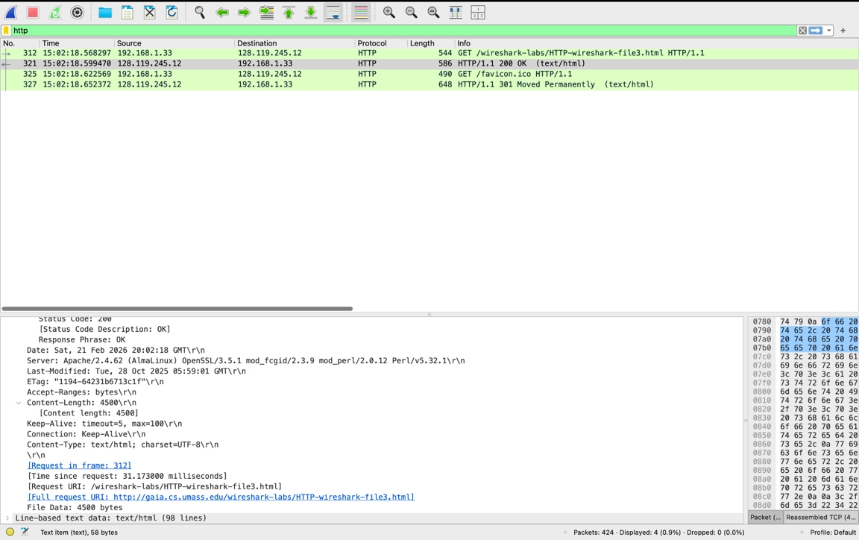
  - 12. As shown in the GET message screenshot, it appears that my computer had only sent one GET message, which is packet number 312 that begins the process.
  - 13. Ultimately, which is shown in the OK message packet line, the packet number that delivers (or assembles) the final product and is the “finalized” OK message with the 200 status code is packet number 321.
  - 14. In packet number 321 I received a status code of 200 and OK, after the TCP packets were reassembled to provide the full Bill of Rights.
  - 15. As shown in the OK message screenshots, it took 4 TCP segments, totaling 4864 bytes, to transport the single HTTP response and full Bill of Rights.
- For Section 4’s two questions, they will be answered sequentially below and preceded by screenshots:
  - Firstly, a general screenshot to see all of the GET and OK messages:
    - 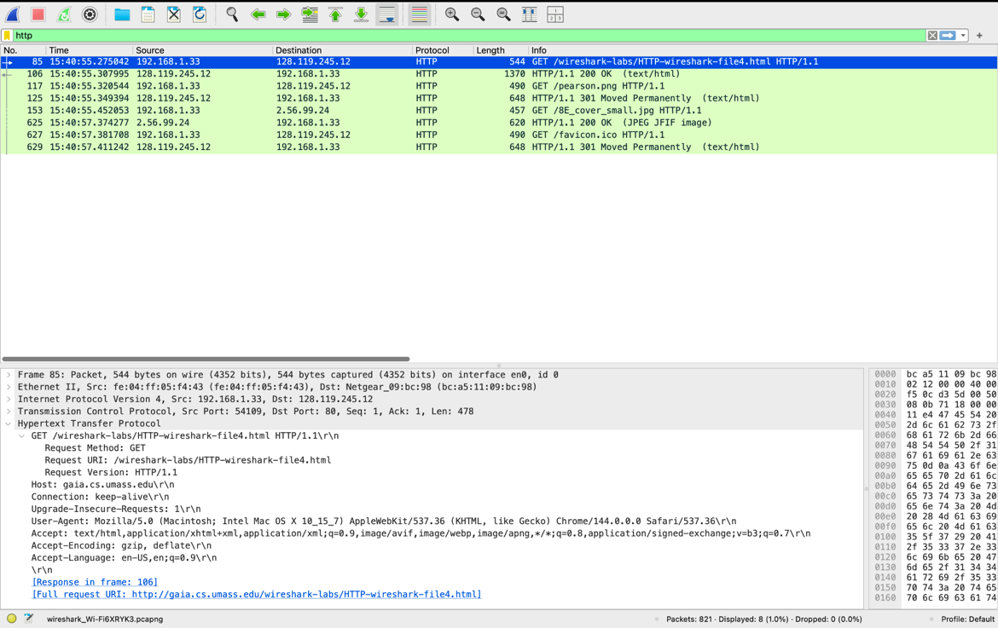
  - The next screenshot will be of the GET message for the Pearson Image:
    - 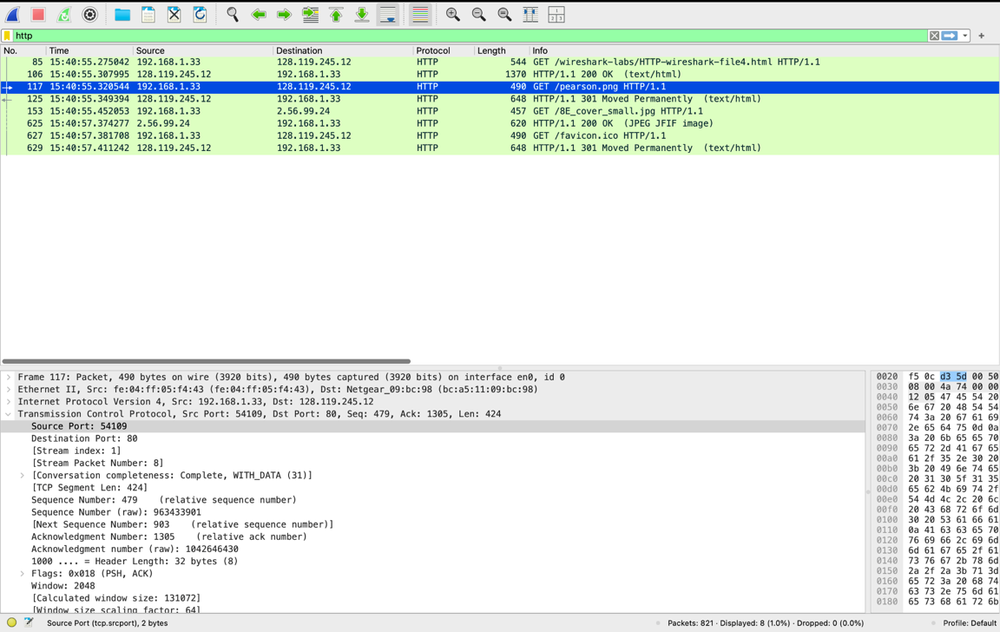
  - This final screenshot will be of the GET message for the Book Cover Image:
    - 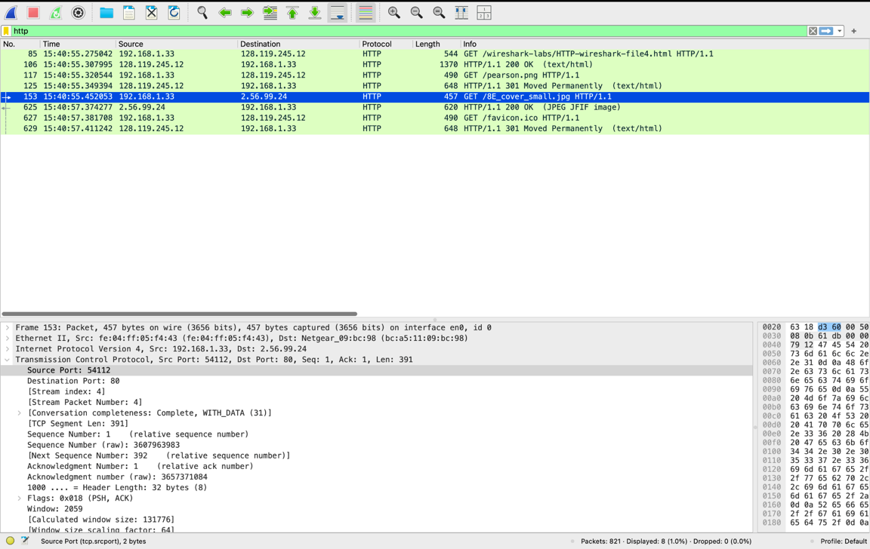
  - 16. Overall, as shown in the general screenshot, there was a total of 4 GET messages that were sent, with the initial being to the server for the URL and to request the contents of the site, the second GET message was to request the Pearson image, the third GET request was for the Book Cover image, and the final GET request was for the icon. As seen in the destinations and sources of these GET requests for the initial URL, and for the URL to the web server for the Pearson image were to the usual web server of 128.119.245.12, but for the Book Cover image URL embedded in the HTML directed my computer to contact another server to receive the image, which is 2.56.99.24.
  - 17. To be able to determine if the GET requests for the two images were done serially or in parallel, you can look at the two GET messages for each of the requests, 117 (GET message for the Pearson image) and 153 (GET message for the Book Cover image). For the Pearson image it shows that it used Port 51409 and the Book Cover image used Port 54112, which gives a good indication that these were done in parallel.
- For Section 5’s two questions will be answered below sequentially and preceded by screenshots:
  - Below will be screenshots of the response to the first GET message to the URL:
    - 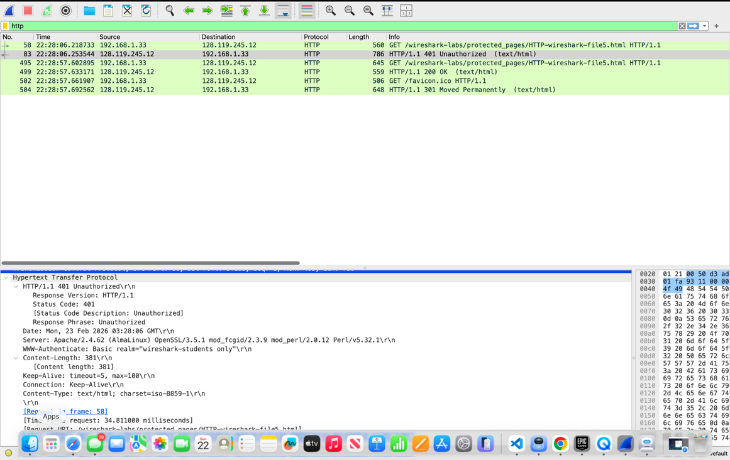
  - Below will be a screenshot of the second GET message, with the username and password being sent to the server:
    - 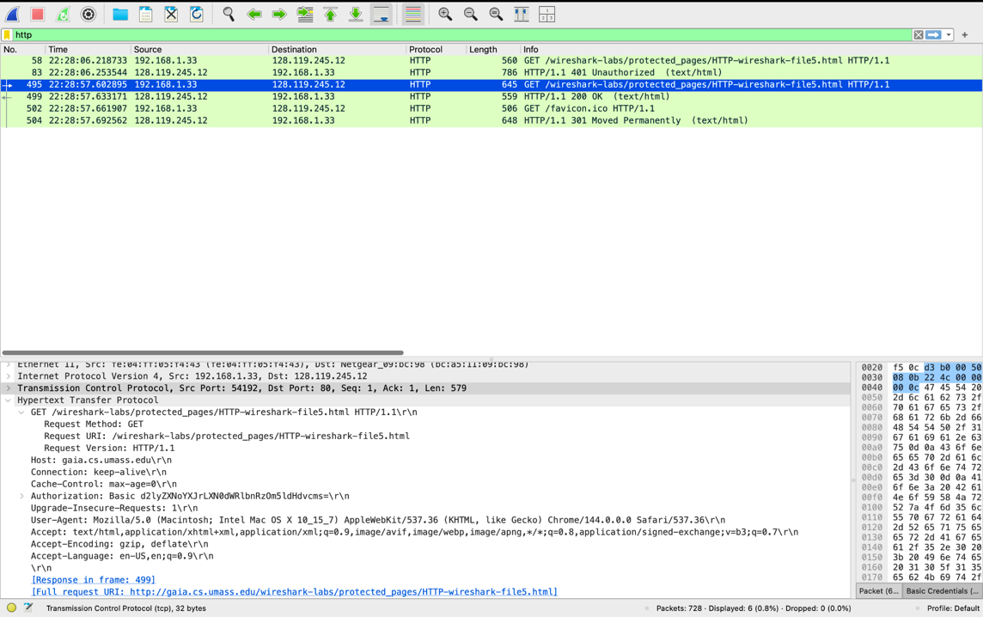
  - 18. The status code and phrase, as shown in the screenshot for the response of the first GET message, is 401 and Unauthorized which displays the request for a username and password on the browser.
  - 19. When the second GET message is sent with the username and password, as shown in the final screenshot, the new header that is included is “Authorization” with a string in Base64 format that the password was encoded in.

